The role of art in our society: A story using data

Introduction – Questions Raised

In this essay we begin by asking the question what are our musical preferences? What shapes our taste in art? What shapes the way we consume culture? And how does it in turn influence our view of the world around us?

When a data person raises a question, they want to know if there is data to answer the question. If there is not data to answer the question directly, we either reformulate our question, or we look for data that can shed light on our narrative. For this purpose, we have done a bit of both.

While ideally, I would have liked to have found data on musical (genre) preferences by race, over time, and see that linked to political affiliation, some of these studies have already been conducted. So I needn’t worry that there is a gaping hole in the research literature.

For my own purposes, however, I contented myself with the SPPA (Survey on Participation in the Performing Arts) data, conducted in conjunction with the Census Bureau. The SPPS is hosted on the treasure trove that is ICPR, at the University of Michigan, Ann Arbor.

The data serves to show us the importance of quantifying communal participation in the arts, so as to better estimate the funding required to keep the arts alive.

This isn’t a piece about why it is crucial to fund the arts and art education, and how subsidizing the arts through taxpayer dollars is a public good many of us neglect to appreciate.

Rather, this expose is based out of my own curiosity on how people across various demographics are participating in arts and culture.

The one minor shortcoming of this survey is that it does not treat the popular musical genres with enough of a fine-toothed comb, but instead sticks to broad brush strokes (no pun intended) in categorizing music. In fact, the SPPA primarily focuses on classical notions of the arts and music, namely opera, classical music, jazz, and salsa – what we might call highbrow, or critically acclaimed art.

Here, salsa can perhaps be regarded as the one liberal genre, that signals openness to experience, with jazz of course being the stereotypical archetype for measuring open or narrowmindedness. You will frequently hear the phrase “all that jazz” uttered by the conservative minded, disdainfully , or, on the rare occasion, the carefree, with an easy going way about them.

Now on to the questions I decided to reformulate my direction to. At expense of seeming rigid while addressing the arts, I will now bulletize my questions:

* What music are the different races listening to?
* What music are the different classes listening to?
* What music are the different regions listening to?
* How have reading habits emerged for the different genders?
* How have reading habits emerged for the different age groups?
* How have reading habits emerged for the different classes?

I will now address these questions through a series of graphs, and provide comment where changes appear to be most salient or noteworthy.

**Musical Participation, By Race**

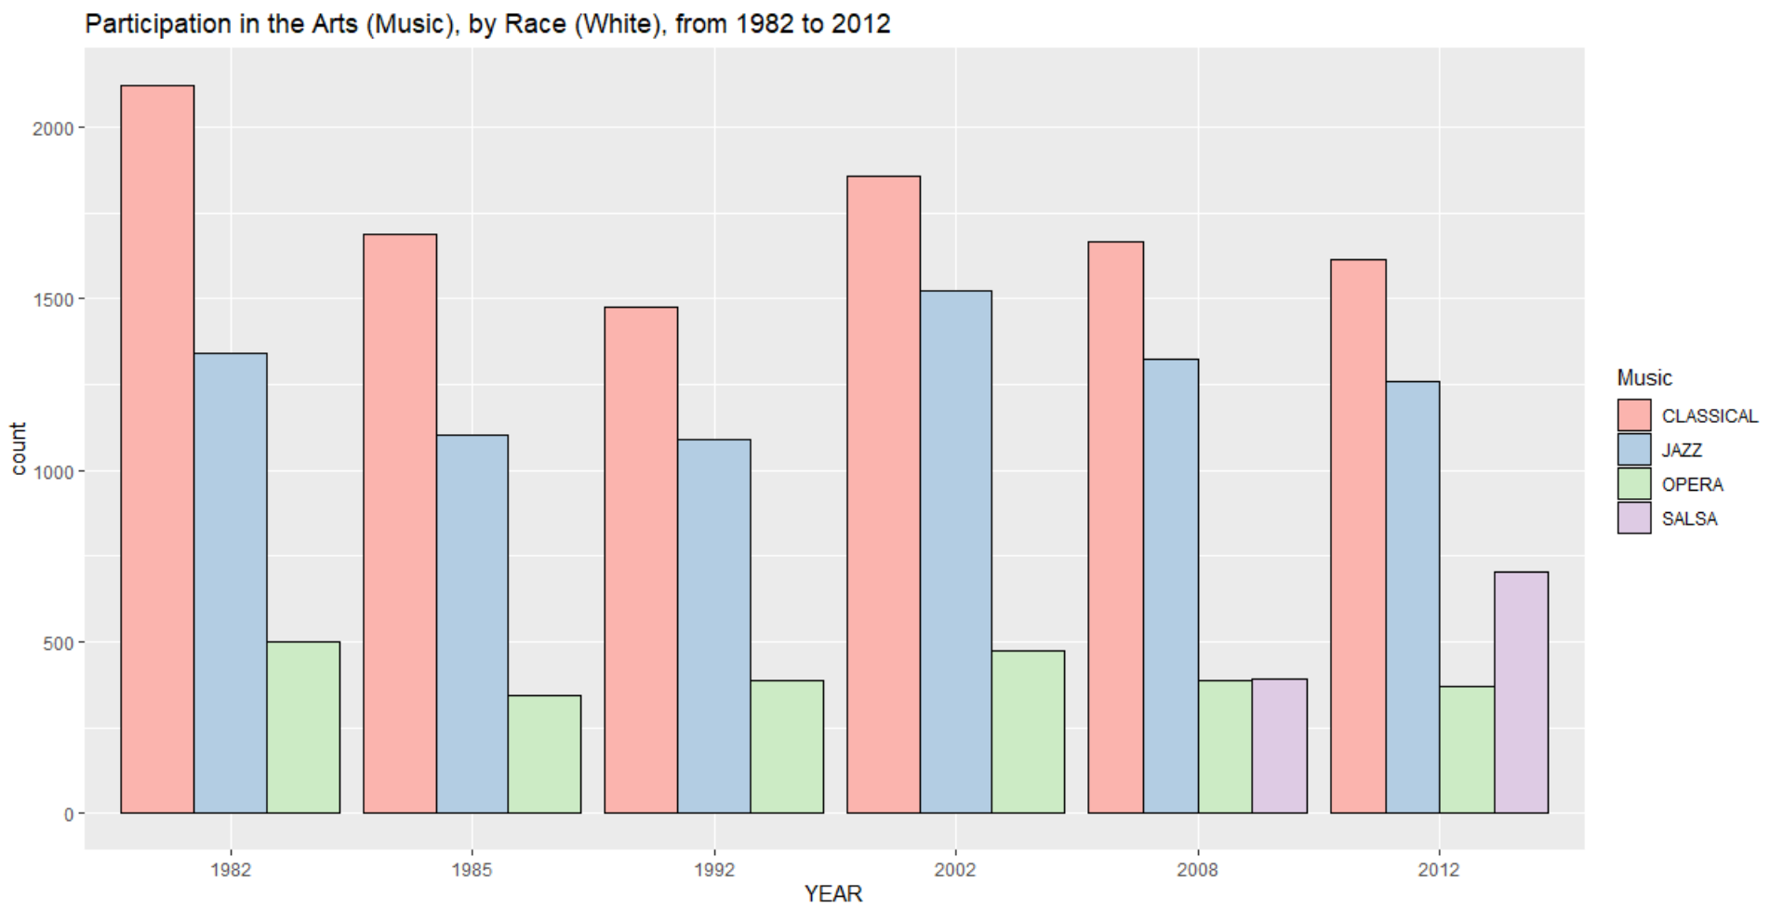

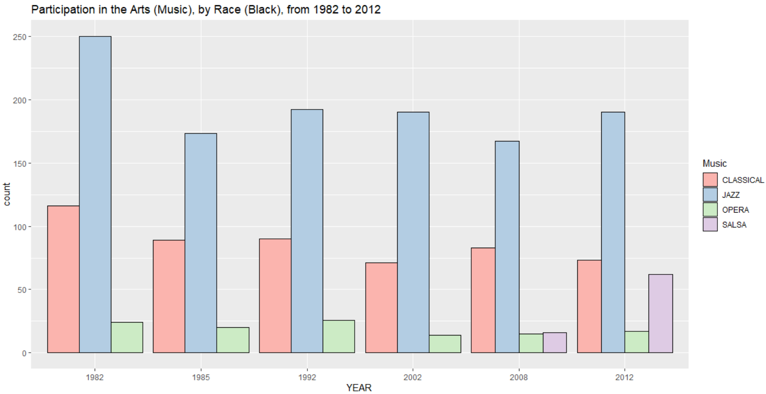

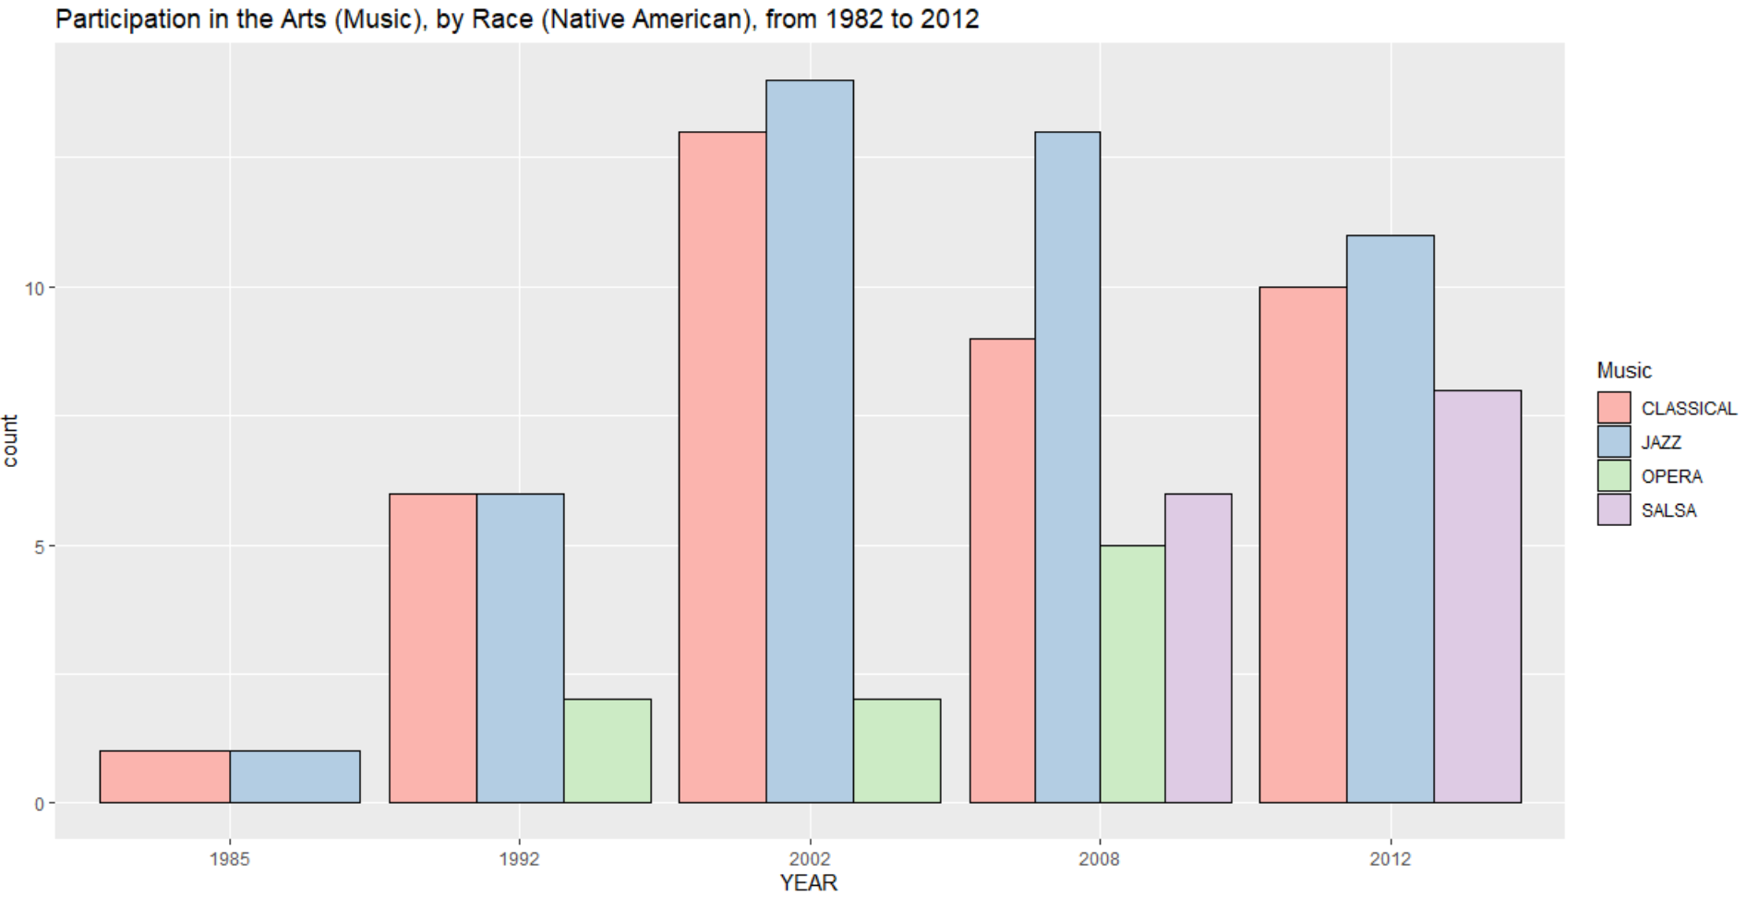

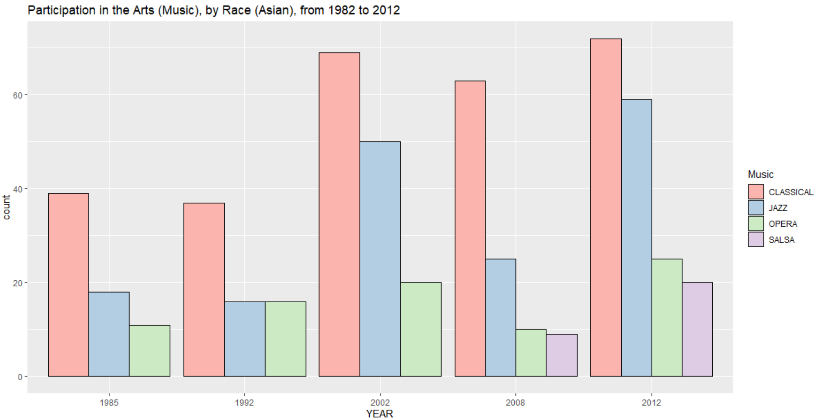

Probably the most delighting fact about the above graphs, is not so much that Jazz seems to have waxed and waned in popularity over the years. Neither is it that classical music has experienced a steady decline, probably owing in part to its byzantine and arcane practices, rituals, infrastructure, and standards of performance. It is more that the Native American population has seen a steady increased participation in the arts, and that the musical performing arts have continually taken stronger root with the Asian population.

**Musical Participation, By Socioeconomic Status**

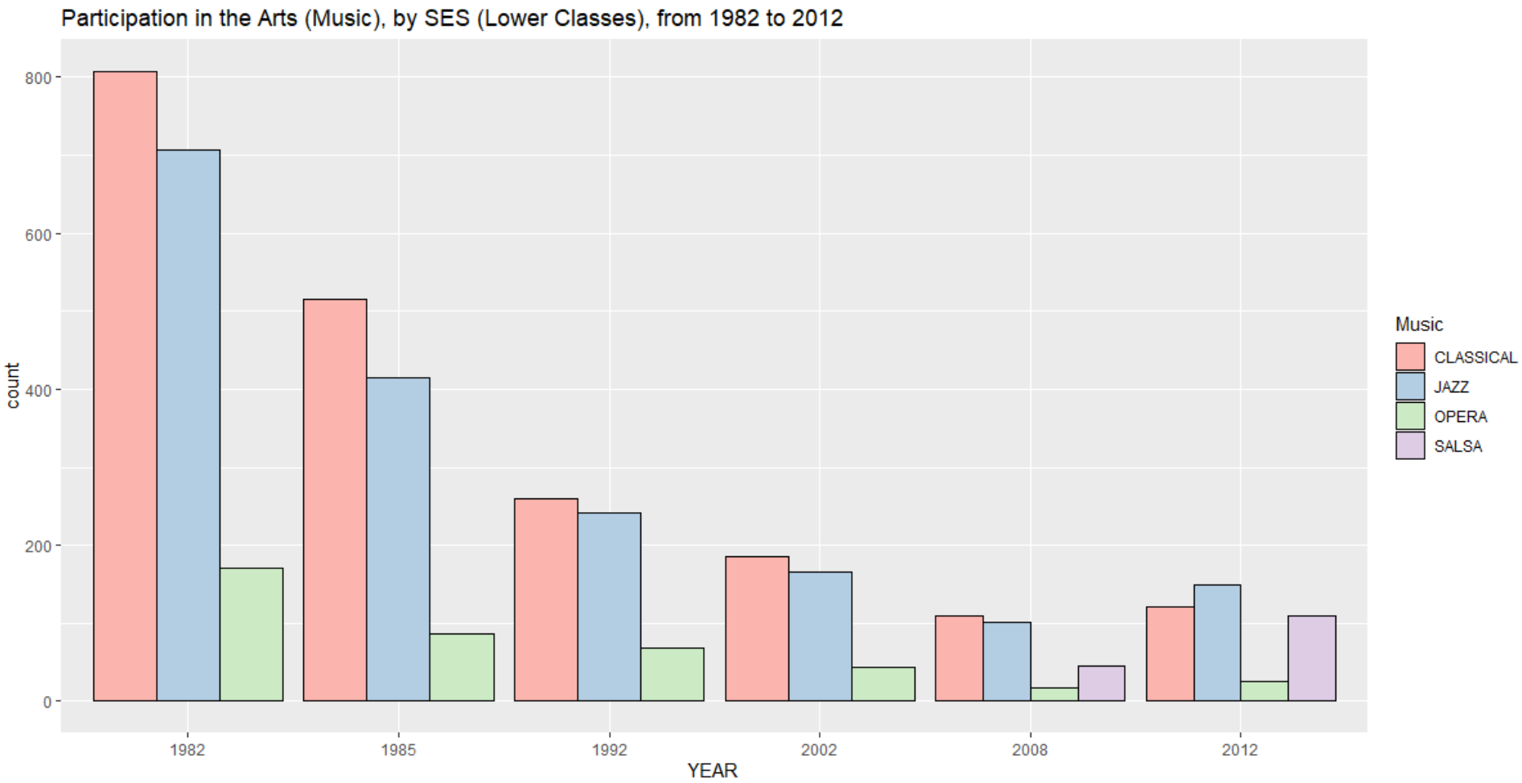

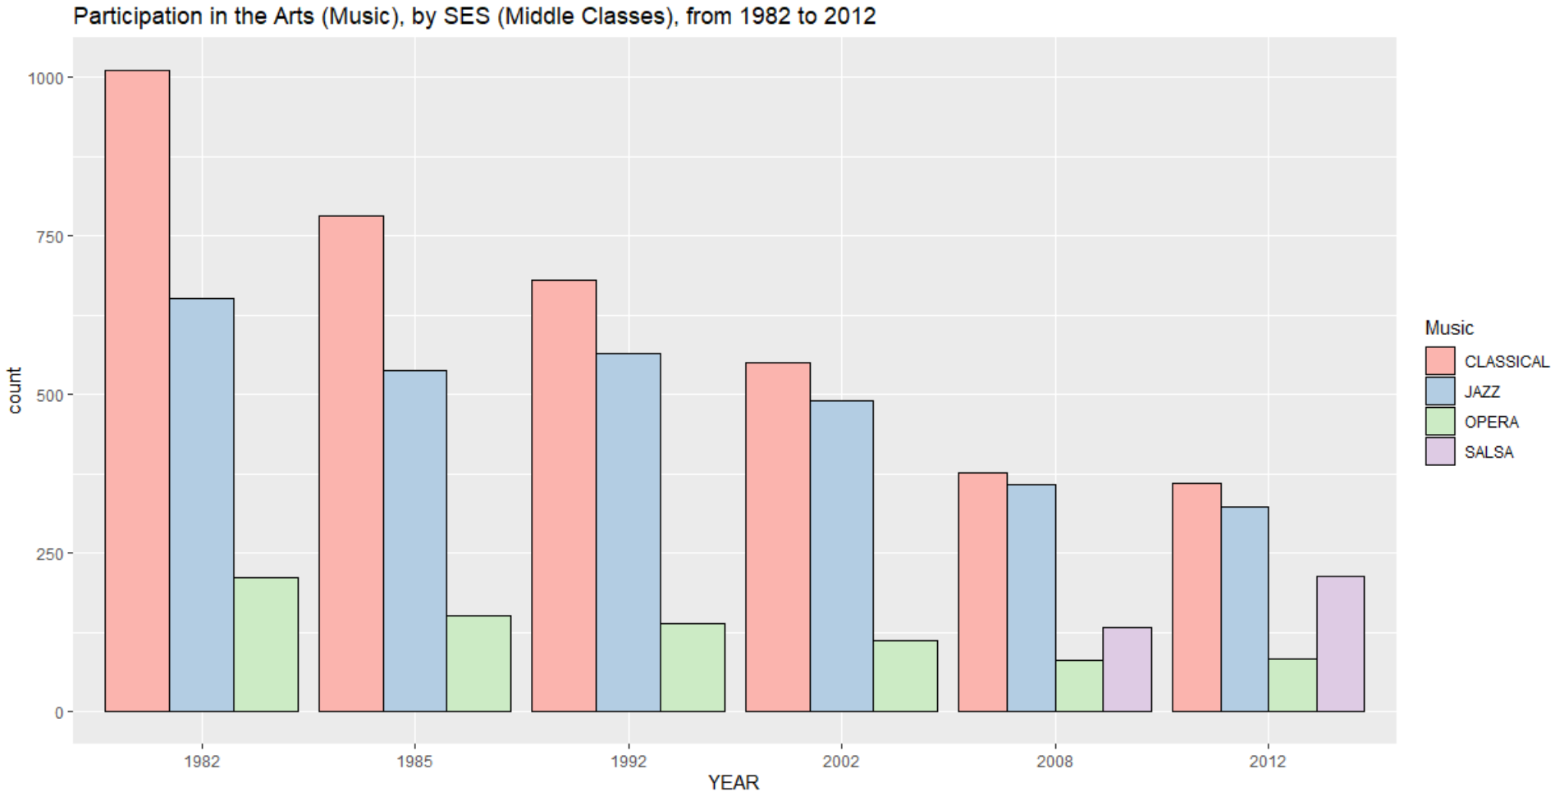

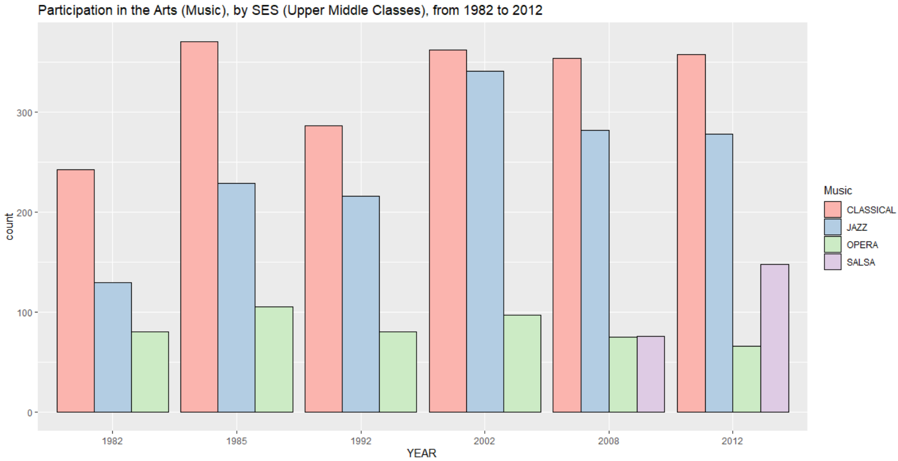

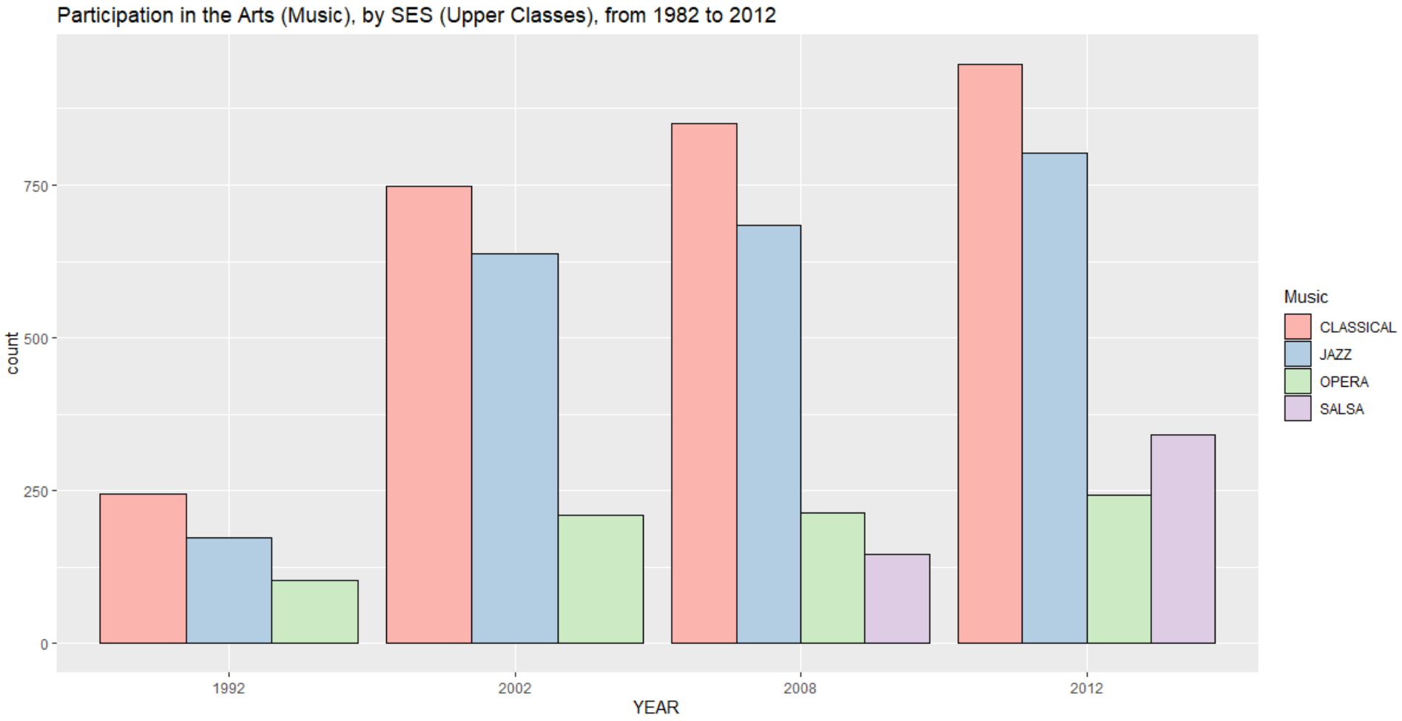

To see that musical participation is a function of available capital, whether in the form of time, leisure, expenditures, or transportation, comes as no surprise to someone who has had to be “on call”. To then note, that the lower-and-middle-income classes have shown a decreased participation in highbrow arts over the years is both a lamentable and an unsurprising fact.

With people at all levels wisening to the importance of financial literacy, and using all types of digital technologies to aid their efforts, it is no surprise people are hesitant to spend their funds on brick and mortar performances requiring buy in, or skin in the game. It’s no surprise there are such high barriers to entry to high brow art. The fault is not that of the arts, or of our institutions. It is merely a matter of scale, and a problem that is difficult to scale without losing quality.

**Musical Participation, By Region**

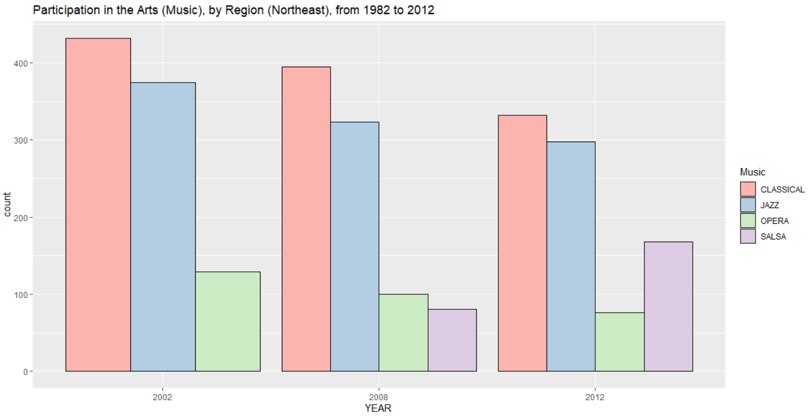

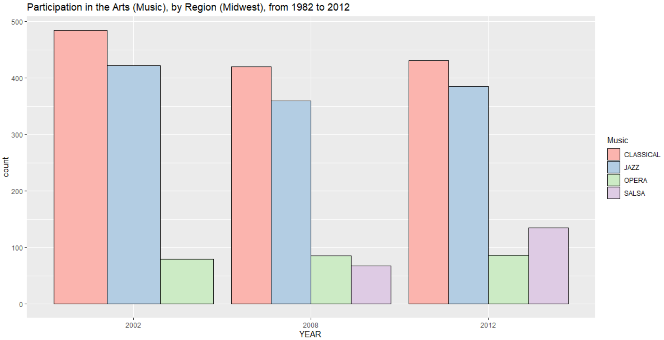

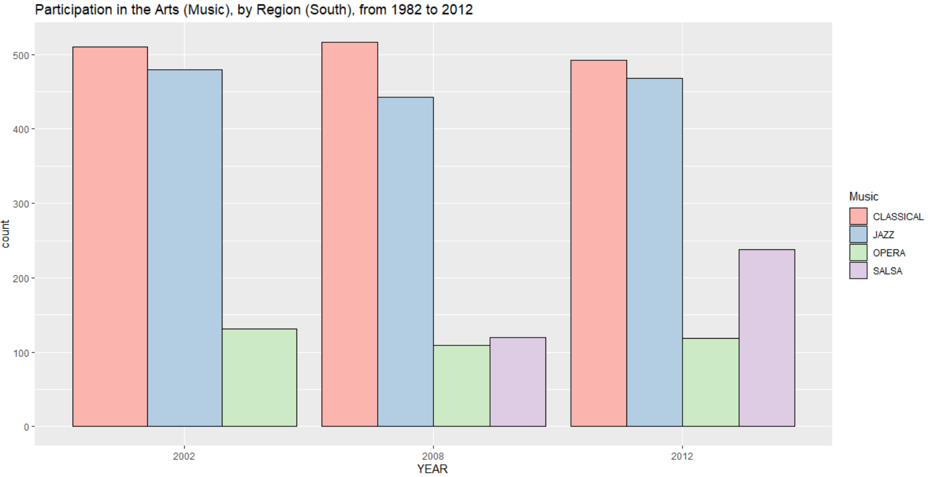

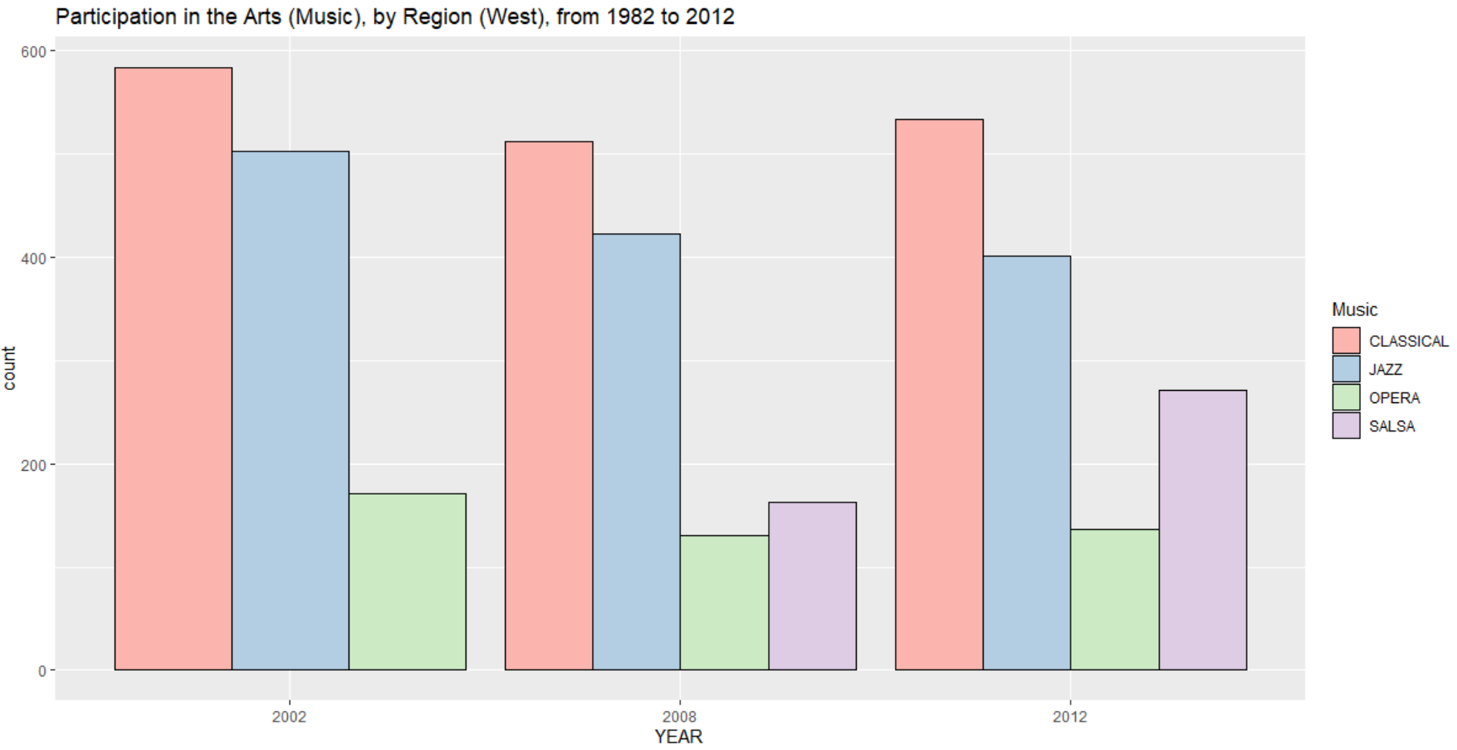

The next set of graphs, cut by region, is a bit more whimsical. Census regions are too broad of a category to comment intelligibly on any trends. Nonetheless, I will note that the northeast, once the beacon of arts and culture in America, has now seen a steady decline in its participation in the musical performing arts, with the West and the South largely picking up the slack, and showing an interest in more worldly categories such as Salsa.

**Reading Participation, By Gender**

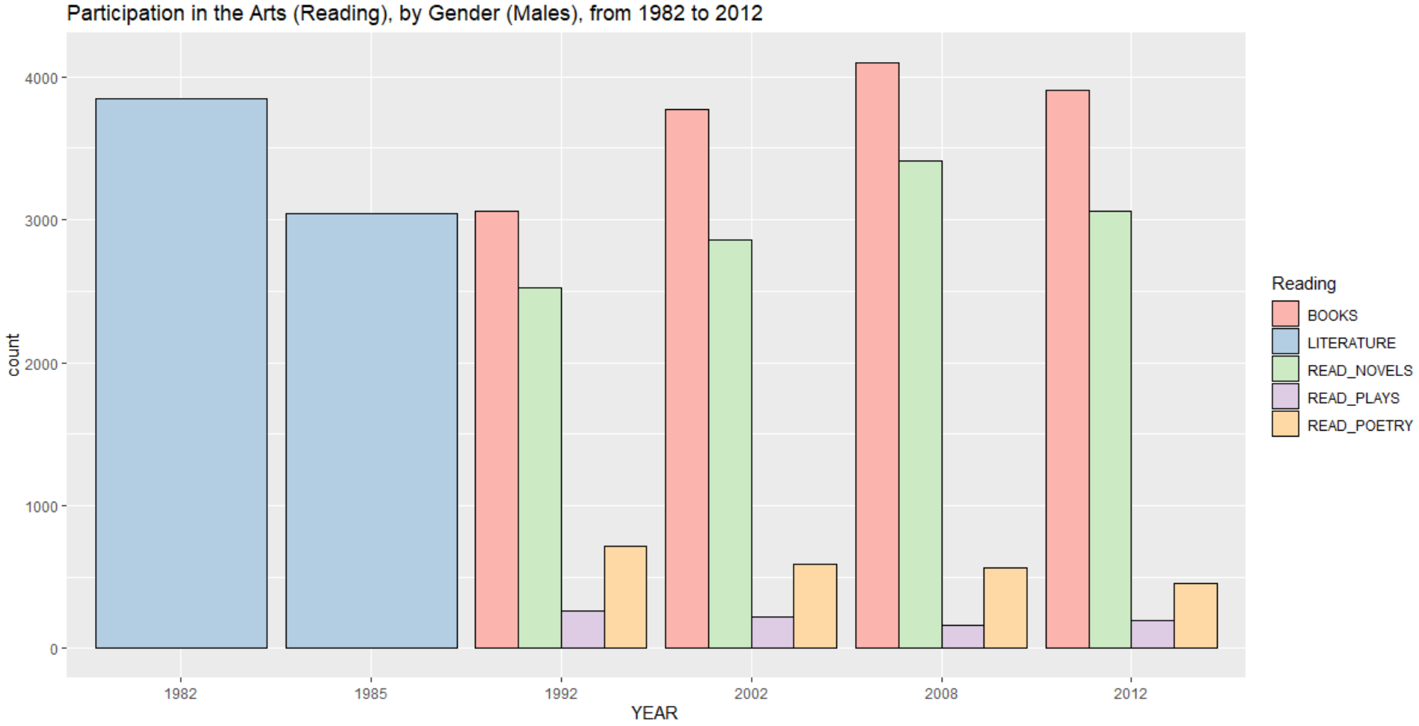

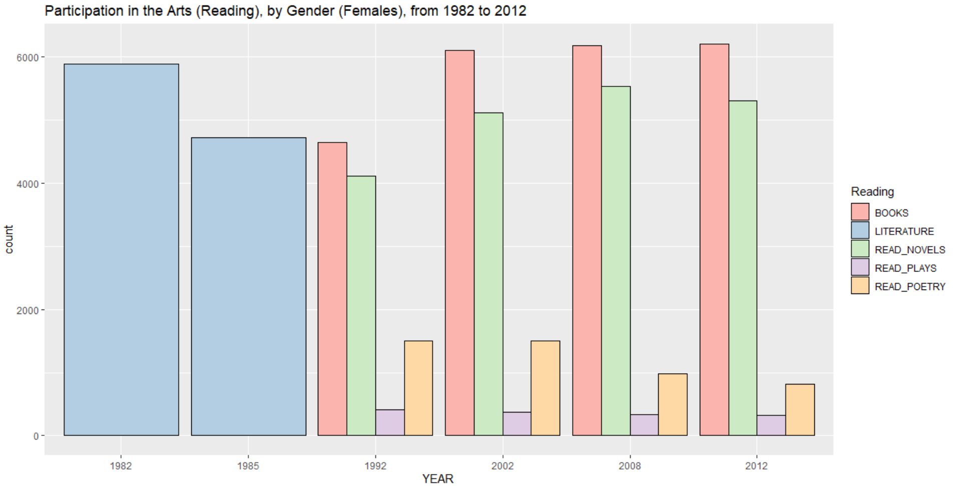

As we foray into reading trends and habits in the past couple of decades, let us begin by noting that before the 1990s, the measure of reading was represented by a single measure, namely ‘literature’. In the years since, this variable has been split into multiple categories, thus preventing any strictly intelligible comment on trendability.

When we begin to look at the graphs by the genders, we would do well to note the absolute numbers. Note that women tend to read books and novels at an almost 50% higher rate than men across all time periods. The measure here check whether the participant read a book in the past 12 months, or a novel respectively.

Additionally, we have also chosen to omit the respondents who said they had not read a book in the previous 12 months. Including this metric would have been useful for measuring the percent changes in the proportion of readers to non-readers over time.

**Reading Participation, By Age Group**

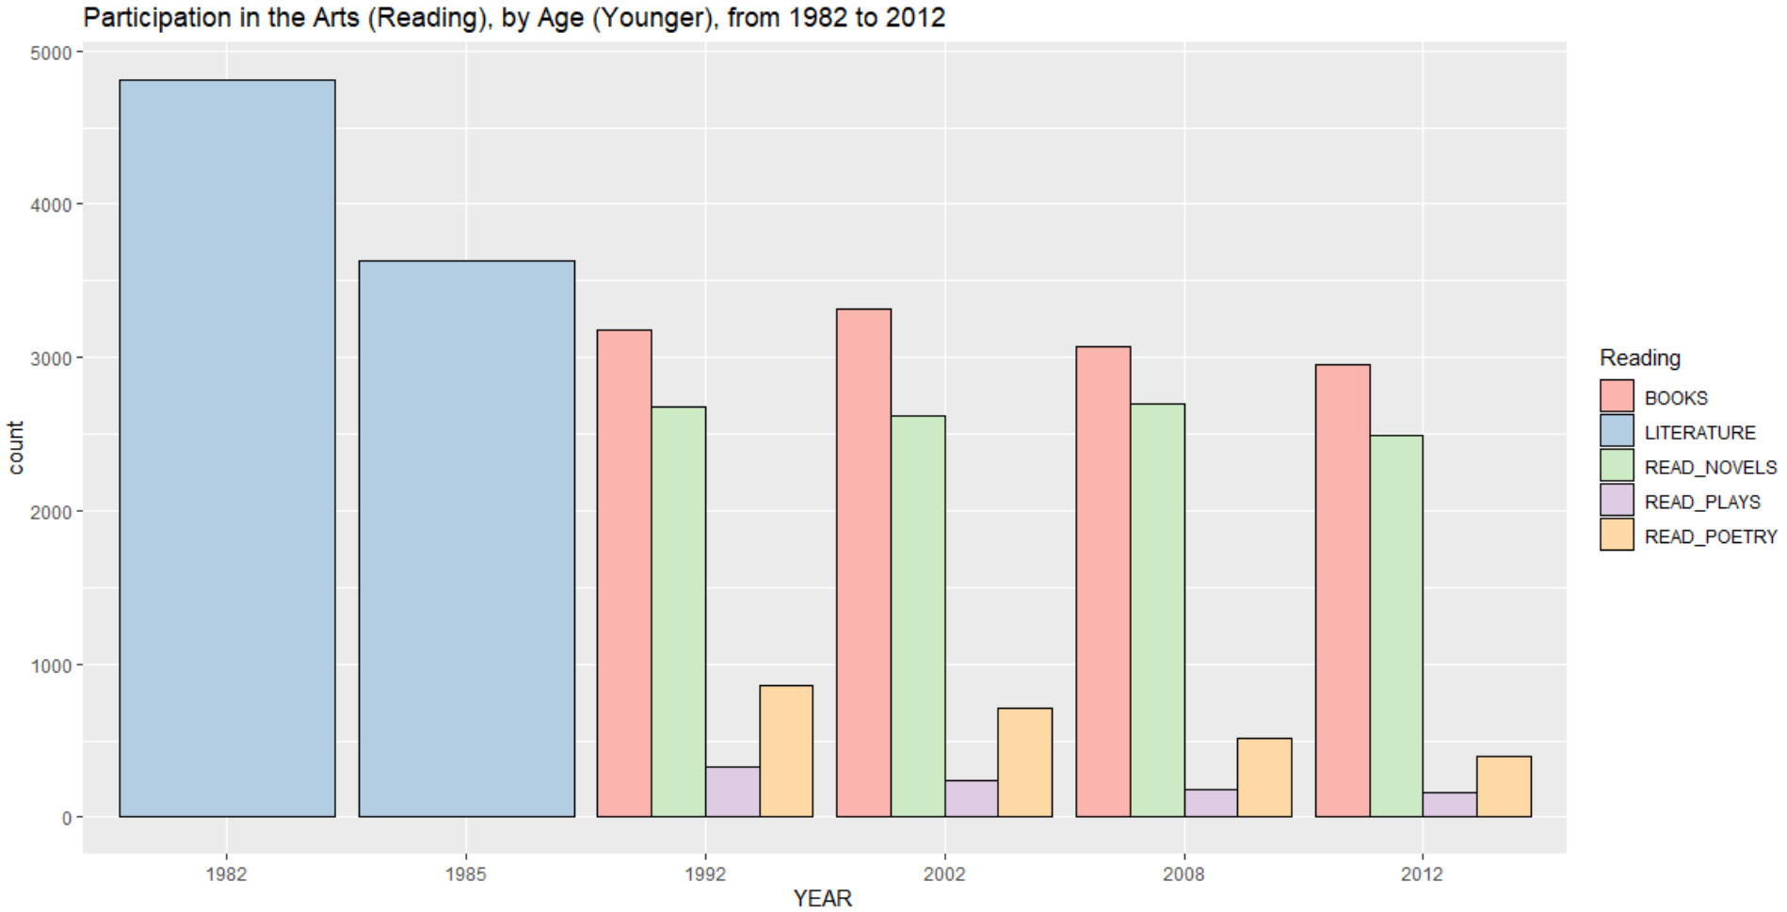

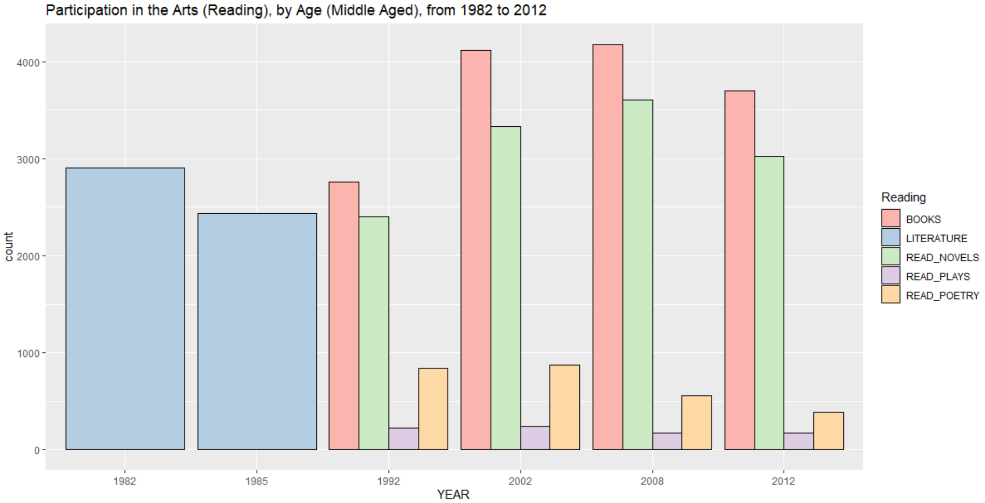

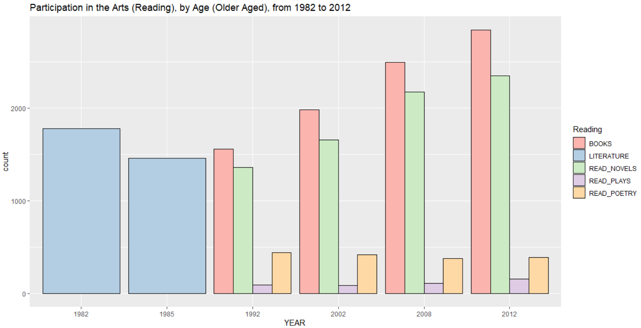

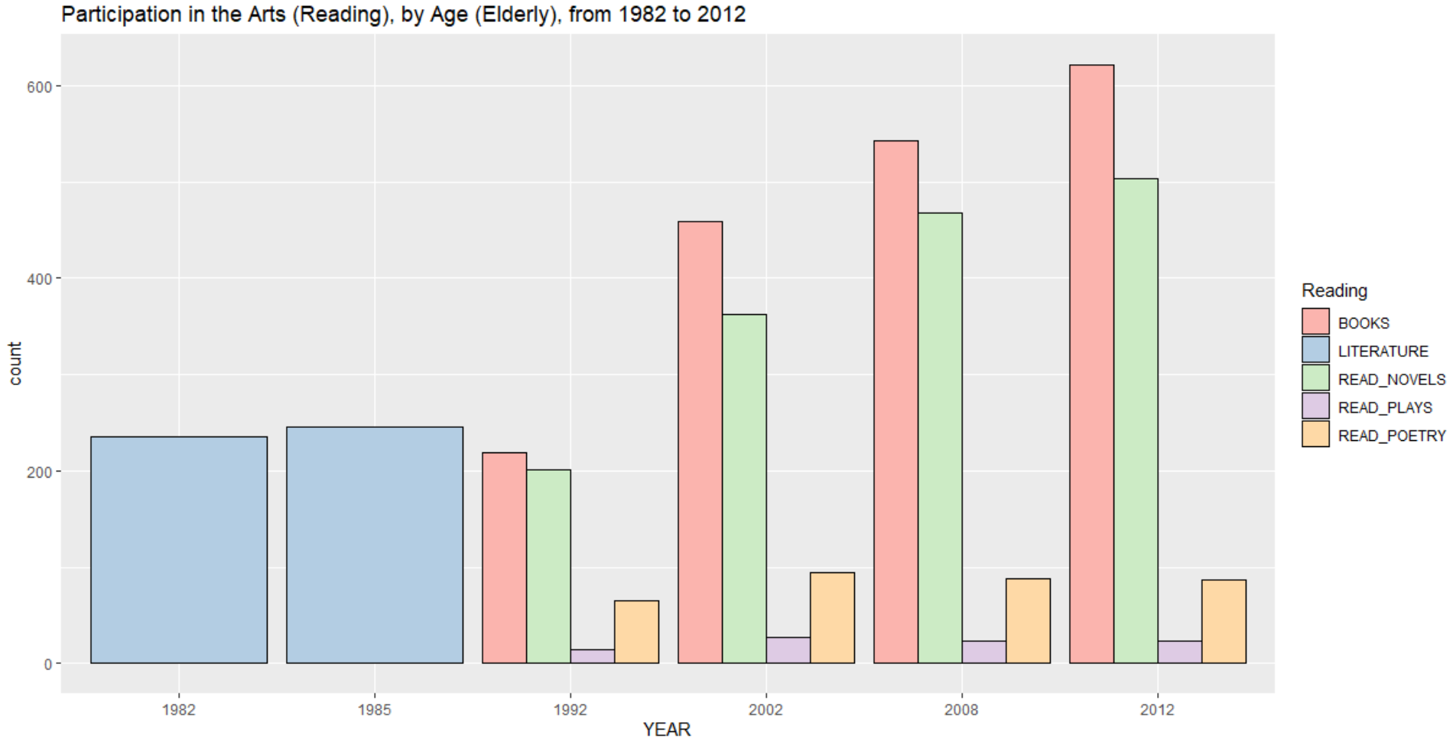

Book reading does not seem to be a very popular hobby among the younger age groups. However, simply due to their sheer numbers, and their college population, the younger age group shows a tepid maintenance in its levels of reading across the years. The older crowd, while smaller in their numbers here, show the steadies increase in the past several years. It could be that with their increased leisure time, and greater access to digital reading material, one of the boons of technology, they have chosen to use it for this purpose. The middle-aged crowd, while largest in number, swells up to point in ’08, then declines briefly in its propensity for reading.

What I find most interesting about these graphs is that while younger age groups showed a declining interest in poetry, and luke-warm interest in plays, older populations showed a resurgence in their love for poetry. I find this heartening, as something that truly captures the essence of arts effect on the soul.

**Reading Participation, By Socioeconomic Status**

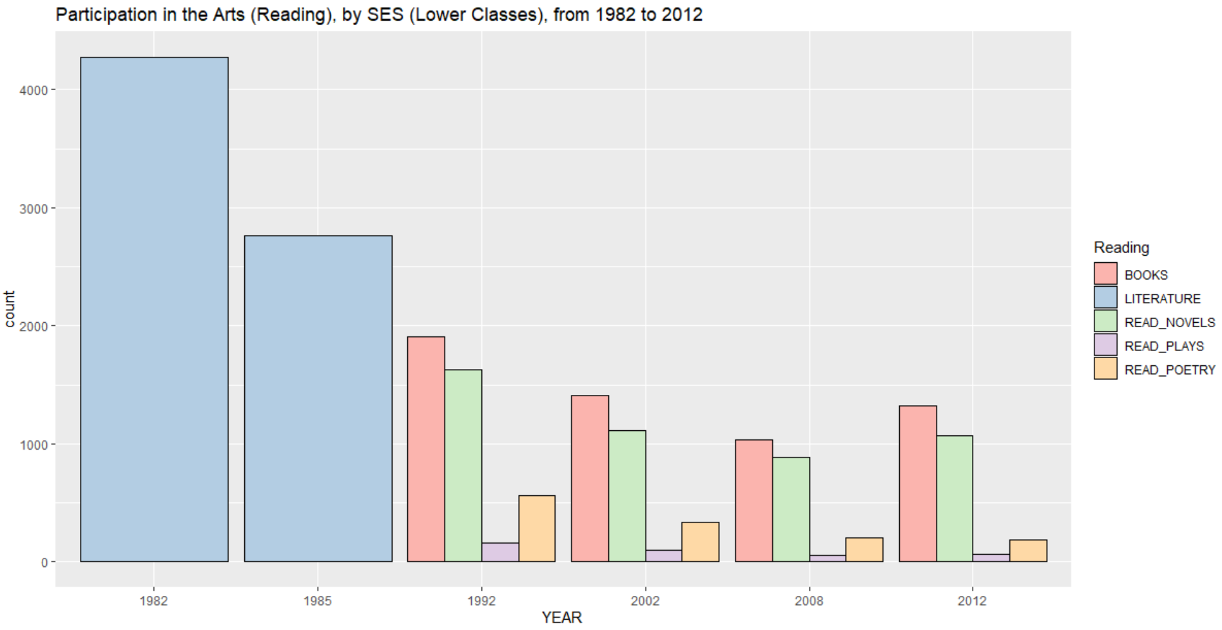

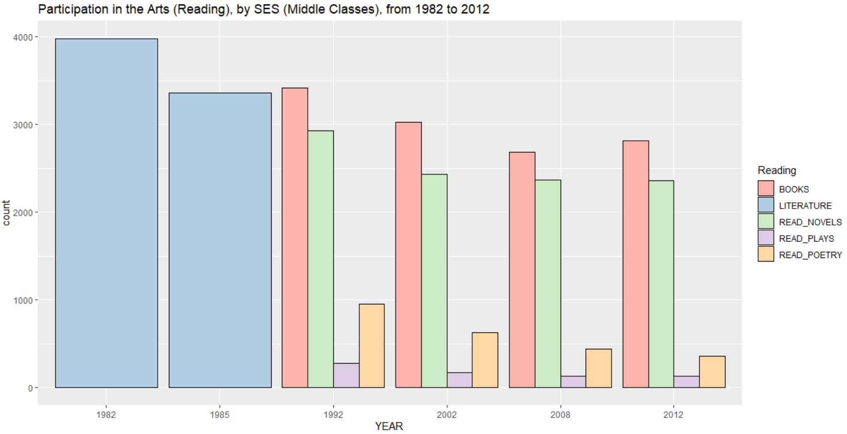

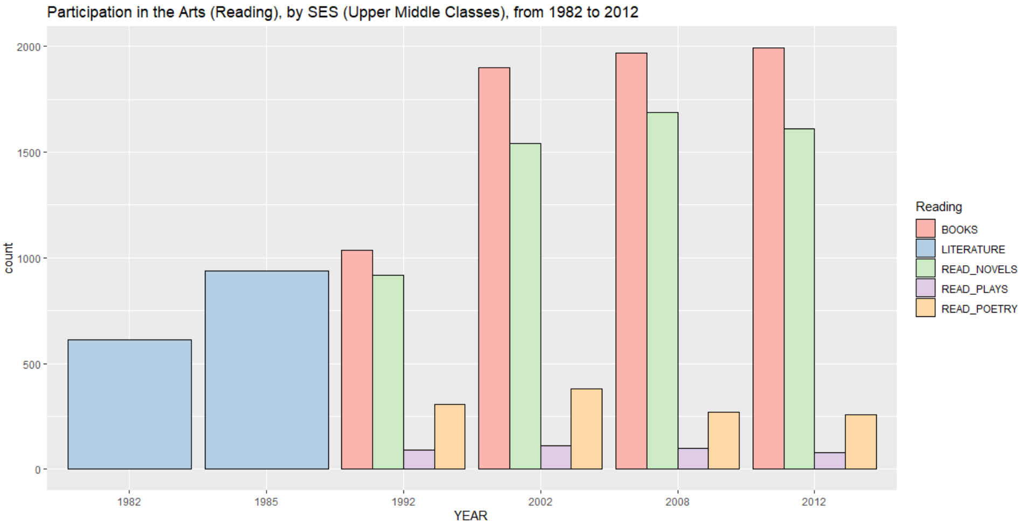

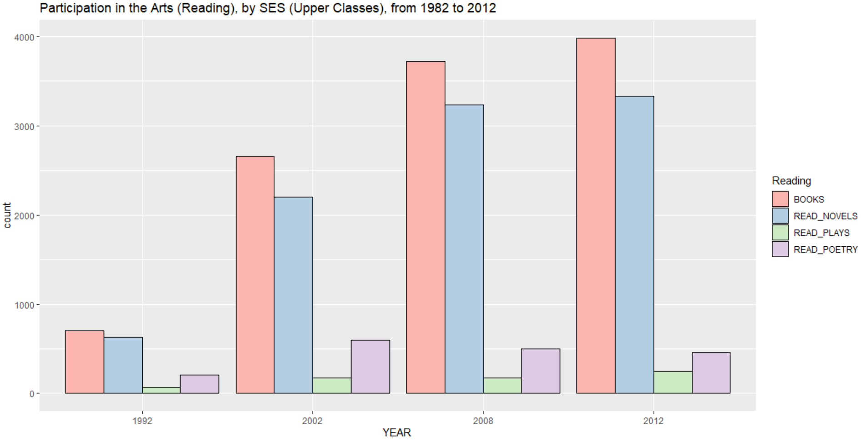

As one might observe, the lower classes are not exactly pre-disposed in their ability for reading, and devote increasingly less time to the practice of doing so. As they find themselves more and more constrained, by the pull of doing more to better their lot in life, the lower classes are unable to free up the time to gain the social and cultural capital necessary for ascending and participating in an informed manner.

The upper classes show promising trends, with regards to their wide reading over the previous decades. With increased accessibility to books, a form of culture that requires mostly time and leisure, and the smallest seed capital, one need not set up the infrastructure necessary for the musical performing arts.

The creation of art may well follow from consuming documented forms of culture, and hand-woven narratives of our condition. And, quite frankly, music may erupt organically. But to have one without the other is to lose something in the process.

Conclusion – Wrap up

The arts form an integral part of our lives. They animate when we least feel inspired. They are often referred to as cathartic, and performing what we cannot bring ourselves to enact in our real lives – hence the appeal of dramatic, over the top, shock comedy. As Alain de Botton put it, what we are drawn to most in art, speaks to what we feeling lacking most in ourselves and in our lives.